**CISC3003: Web Programming**



**Project Title**

***The Pet Home Website***

**Submitted by Team 01:**

|  |  |  |
| --- | --- | --- |
| Pair No | Student ID | Student Name |
| Pair05 | DC126114 | LEI CHAK FONG |
|  | DC125943 | WONG CHI CHON |
| Pair08 | DC025027 | AO CHI LAM |
|  | DC027857 | WANG XINYU |
|  | DC027353 | CAO YUTING |
| Pair21 | DC026157 | WONG KAI YUAN |
|  | DC328783 | JOÃO PAULO MONTEIRO BARROS CEVA RODRIGUES |

**Contents:**

**Section 01: Abstract**

**Section 02: List of Services**

**Section 03: List of Task**

**Section 04: Project Accomplishment**

**Section 05: Project Walkthrough and Showcase**

**Section 06: Installation Instruction**

**Section 07: Project Self-Assessment**

**Section 01: Abstract**

In this semester, as part of our CISC3003 Web Programming course, we have delved into the intricacies of four cornerstone web technologies: HTML, CSS, JavaScript, and PHP. The culmination of our studies is demonstrated through this project, where we’ve applied our knowledge to create a comprehensive online platform, PetHome.

PetHome is a social community website tailored to the interests of pet owners and enthusiasts. It serves as a digital space where users can register accounts, share delightful moments with their pets, and engage in a variety of interactive activities. The platform facilitates community discussions on pet care and offers an informative blog filled with tips and stories from fellow pet lovers. Additionally, PetHome includes a dedicated store page, providing a curated selection of pet products.

The construction of the website is rooted in HTML and CSS for structuring and styling, while JavaScript has been integrated to enhance interactivity and improve user engagement. The backend architecture utilizes PHP in conjunction with a MySQL database, which securely manages user data and ensures seamless site functionality. Designed with responsiveness in mind, PetHome guarantees an exceptional user experience across multiple devices.

This project not only validates our learning outcomes but also exhibits a comprehensive set of technical competencies, encompassing both client-side and server-side development, database integration, and responsive web design.

**Section 02: Project List of Services**

1. Login/Registration service:   
   PetHome offers a streamlined account registration process enabling users to join our pet-loving community. Once registered, users can log in to participate in discussions, post messages, and engage with other community activities.
2. Forum service:   
   Our community forum is the heart of PetHome, where users can share delightful anecdotes, post pictures of their pets, and engage in meaningful conversations with fellow enthusiasts.
3. Blog service:   
   Pet owners can read and contribute to a wealth of articles in the blog section, sharing their knowledge and stories, as well as participating in themed blogging events and challenges to highlight their pets' adventures.
4. Store service:   
   The store page allows users to browse through a carefully curated selection of pet products. From food to toys, all items reflect the latest trends and the highest standards of pet care.
5. User List service:   
   Users can find like-minded friends and chat with them on the user list page.
6. Personal Homepage service:   
   Each member receives a personal dashboard to curate their own posts, track their activities, and personalize their PetHome experience with photos and updates about their pets.
7. Personal Profile service:   
   Each user has their own profile page, which allows them to fill in their personal information so that others can quickly understand themselves.
8. Database service:   
   The backend database can record user settings, messages, and photos so that users can easily manage their activities and content on the website.

**Section 03: Project List of Tasks**

|  |  |
| --- | --- |
| Sign up page | DC027353  Cao YuTing |
| Log in page |
| Profile page |
| * PHP for backend connection * HTML and CSS for page design * PHP and JS for warning alert * Automatically mailing verification |
|
| Home page | DC025027  Ao ChiLam |
| * HTML and CSS for page design * Overall style design |
|
| Forum page | DC027353  Cao YuTing,  DC027857  Wang XinYu |
| Post page |
| * HTML and CSS for page design * PHP for backend connection * PHP and JS for warning alert * OS operation for upload file |
| Blog page | DC027353  Cao YuTing |
| * HTML and CSS for page design |
| Store page | DC025027  Ao ChiLam |
| Store Page (Cat) Store Page (Dog) Store Page (Pet Supplier) |
| Cart page |
| * HTML and CSS for page design * PHP for backend connection * PHP and JS for warning alert * Complete calculating the subtotal/total price function |
| Reset page | DC027857  Wang XinYu |
| * PHP for backend connection * HTML and CSS for page design * PHP and JS for warning alert * Automatically mailing verification |
|
| Header & footer | DC025027  Ao ChiLam,  DC027353  Cao YuTing,  DC027857  Wang XinYu |
| Navigation Bar |
| Images |
| Textual Information |
| PHPMAILER set up |
| Verify email |
| Database service | DC025027  Ao ChiLam,  DC027353  Cao YuTing,  DC027857  Wang XinYu |
| * Database creation * Database table creation * Database record insert * Database management * Backend for login/registration * Backend for user, post, product information * Backend for verification |
|

|  |  |
| --- | --- |
| PPT - Cover page | DC126114  LEI CHAK FONG  DC125943  WONG CHI CHON |
| * Project title * Team number * Team member (Student ID + Student name) |
| PPT - Content | DC126114  LEI CHAK FONG  DC125943  WONG CHI CHON |
| PPT - Introduction | DC126114  LEI CHAK FONG  DC125943  WONG CHI CHON |
| * Pet supplies e-commerce website * Clear categories and search capabilities * Top brands and manufacturers |
| PPT - Our goal | DC126114  LEI CHAK FONG  DC125943  WONG CHI CHON |
| PPT - The main services | DC126114  LEI CHAK FONG  DC125943  WONG CHI CHON |
| * Login\Register * Community Forums * Blog * Store page |
| PPT - User workflow | DC126114  LEI CHAK FONG  DC125943  WONG CHI CHON |
| * Shopping * Engagement * Knowledge expansion |
|
| PPT - Our target user | DC126114  LEI CHAK FONG  DC125943  WONG CHI CHON |
| * Novice Pet Owners * Experienced Pet Guardians * Urban Pet Lovers * Community Seekers * Conscientious Shoppers |
| PPT - Technical vision | DC126114  LEI CHAK FONG  DC125943  WONG CHI CHON |
| * HTML and CSS * PHP * MYSQL * PHPMAILER |
| PPT - Web page introduction | DC126114  LEI CHAK FONG  DC125943  WONG CHI CHON |
| * Sign up page * Login page * Reset page * Verify email * Home page * Forum & Post page * Blog page * Store page * Profile page * Shop page * Product & Cart page |
| Video editing | DC126114  LEI CHAK FONG |

|  |  |
| --- | --- |
| Proposal- Research and Background Study | DC026157  WONG KAI YUAN  DC328783  PAULO |
| - Gather data on pet supply e-commerce trends.  - Analyze competitor platforms and identify unique aspects for PetHome. |
| Proposal Writing | DC026157  WONG KAI YUAN  DC328783  PAULO |
| Report | DC026157  WONG KAI YUAN  DC328783  PAULO |
| - Organize chapters and sections according to the project's scope and objectives.  - Develop a consistent format and style guide for the entire report. |
| Report – More detailed background study | DC026157  WONG KAI YUAN  DC328783  PAULO |
| Report - The main services | DC026157  WONG KAI YUAN  DC328783  PAULO |
| * Login\Register * Community Forums * Blog * Store page |
| Report - Content Creation | DC026157  WONG KAI YUAN  DC328783  PAULO |
| - Write detailed analyses on PetHome's market position and technical implementation.  - Include user interaction models and feedback mechanisms. |
|
| Report - Review and Editing | DC026157  WONG KAI YUAN  DC328783  PAULO |
| - Ensure all information is accurate and well-presented.  - Revise drafts based on feedback from peers and advisors. |
| Report - Finalization | DC026157  WONG KAI YUAN  DC328783  PAULO |
| - Compile all sections, ensure formatting is uniform.  - Prepare the final document for submission. |
| Technical Documentation | DC026157  WONG KAI YUAN  DC328783  PAULO |
| - Document the software architecture and framework.  - Detail the development process including code snippets and database schema.  - Outline the security measures implemented in the user registration and login processes. |
| Presentation Preparation | DC026157  WONG KAI YUAN  DC328783  PAULO |

**Section 04: Project Accomplishments & Incomplete**

|  |  |
| --- | --- |
| 1. Login/Registration service | Complete |
| 1. PHP & JS for backend connection 2. HTML and CSS for page design 3. PHP and JS for warning alert 4. Automatiaclly mailing verification |
|
| 1. Forum service | Complete |
| 1. Established PHP backend connections for dynamic forum post updates and interactions. 2. Developed the forum page layout with HTML and CSS for a user-friendly interface. |
| 1. Blog service | Complete |
| 1. Structuring HTML and CSS for the blog page design. 2. Planning the blog content management system using PHP. |
| 1. Store service | Complete |
| 1. User List service | Complete |
| 1. Personal Dashboard service | Complete |
| 1. Php for backend connection 2. JS and php for showing the information of post |
|
| 7. Personal Profile service | Complete |
| 8. Database service | Complete |
| 1. Backend for login/registration 2. Backend for post information 3. Backend for verification 4. Database creation 5. Database table creation 6. Database record insert 7. Database management |
|

**Project Incomplete**

|  |  |
| --- | --- |
| Payment | Incomplete  Legal issues  Protocal issue  Capital limitation |
| Recommendation algorithm |
| Social media account login |

**Section 05: Project Walkthrough and showcase**

1) Sign Up Page

* Input boxes for sign up information collection.
* Button to submit information (can only success submit if input all required information, and repeat password same with set password, and click agree checkbox)
* Submitted information stored in table ‘user’
* After success submission, a verify email is sent to the input email box, account is activated after verify.
* Link to login page.

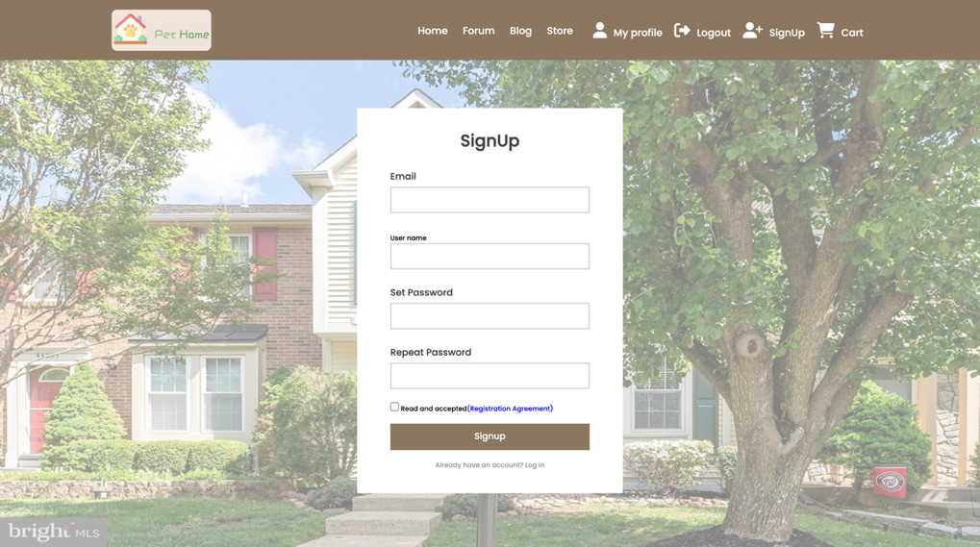

2) Login Page

* Input boxed for log in information.
* Button to submit information (can only success if all input boxes have content, email is registered, password is correct - same with recorded password in database)
* If input email is not registered, go to sign up page.
* Links to sign up page and reset page.

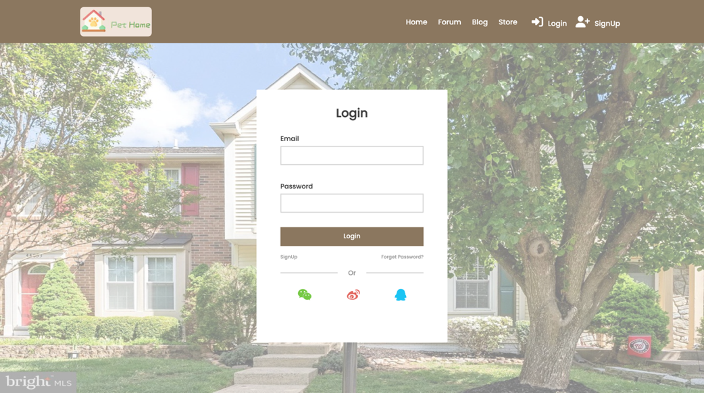

3) Reset Page

* Input boxed for reset password information.
* Button to submit information (can only success if all input boxes have content and reset password same with confirm password)
* After successful submission, a verify email is sent to the input email box, new password is activated after verify.

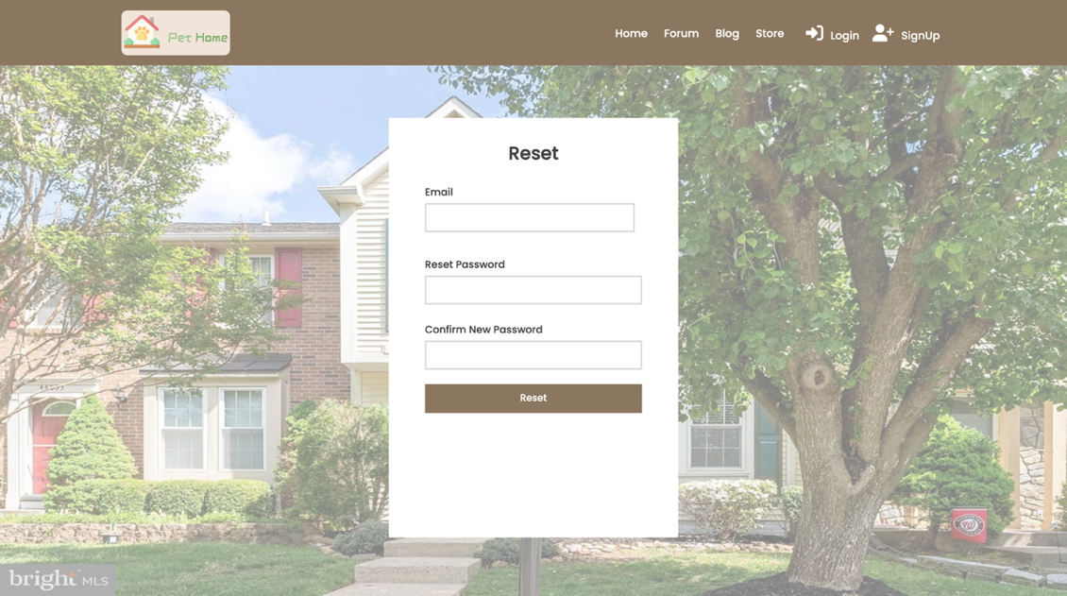

4) Verify Email

* Automatically send to mailbox.
* Include the register name of user.
* Button to verify sign up / reset password, link back to log in page.
* Not actually able to report error.

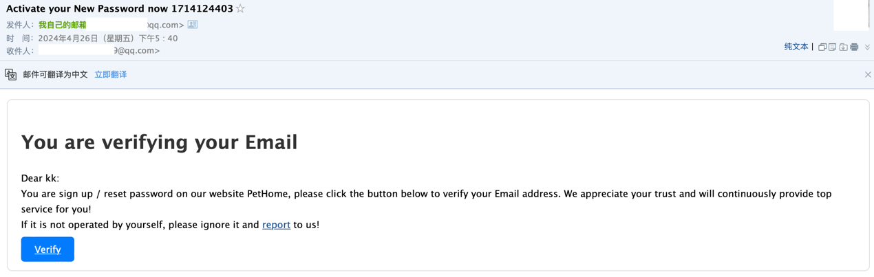

5) Home Page

* Display discount information, daily special, best seller and blog recommendation

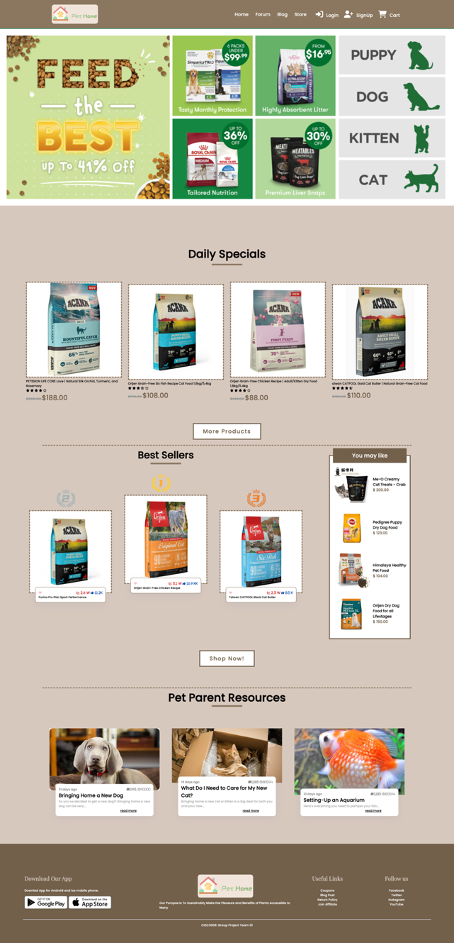

6) Forum Page

* Blog list of all blogs
* Button to post a post (when logged in, otherwise link to login page)

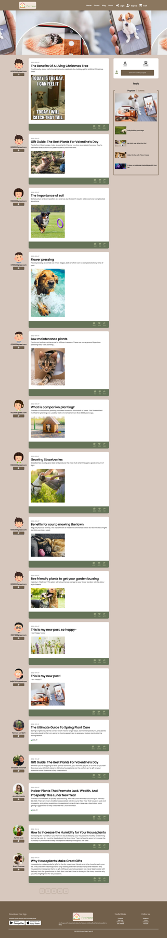

7) Blog Page

* Blog display

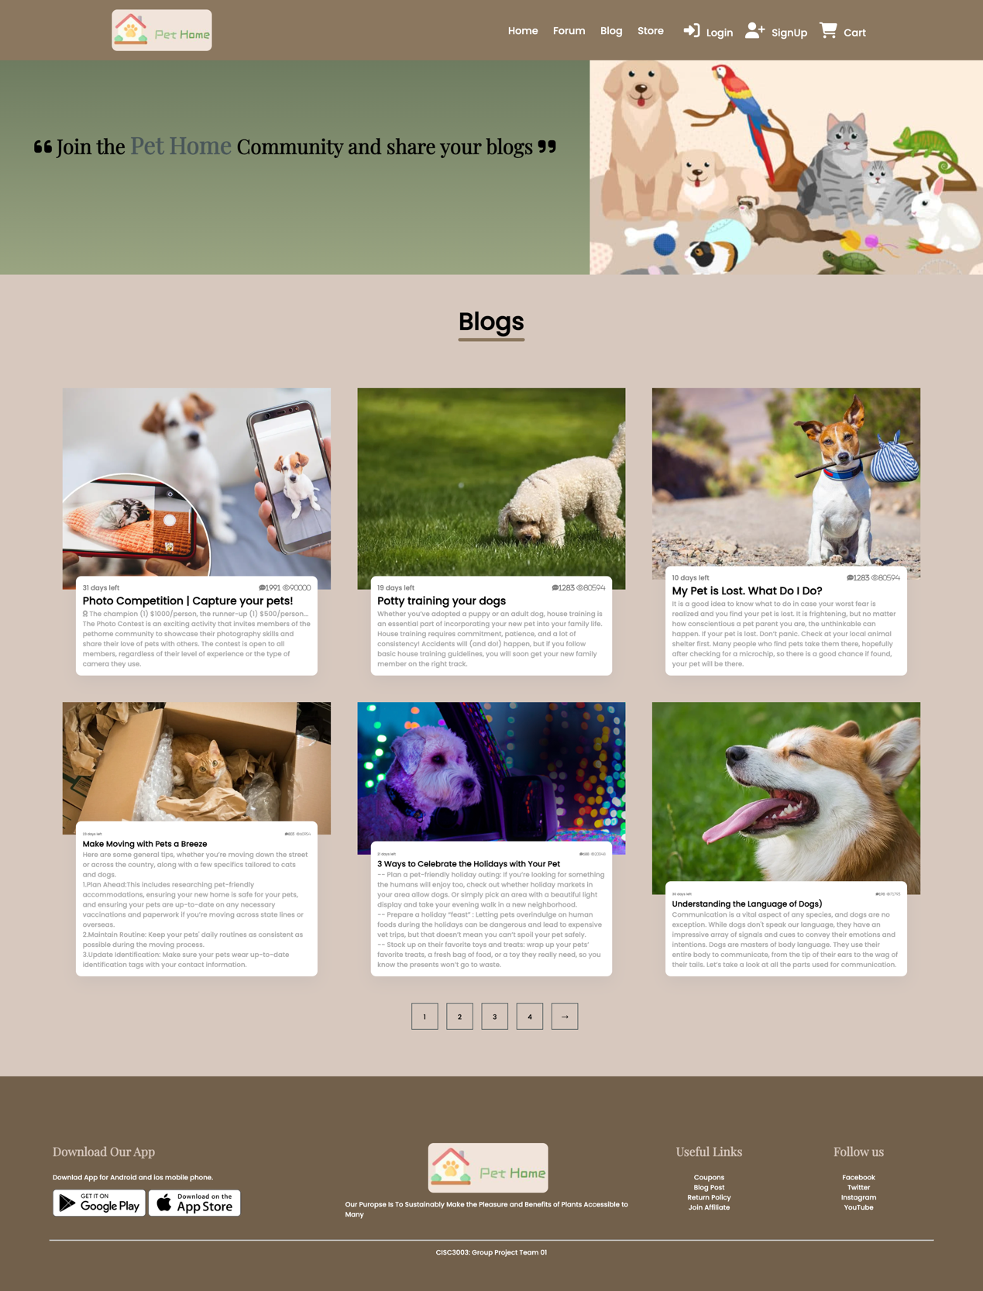

8) Store Page

* items demonstration for cats, dogs and pet supplies
* Button to enter these shops
* Can click the image to enter product page

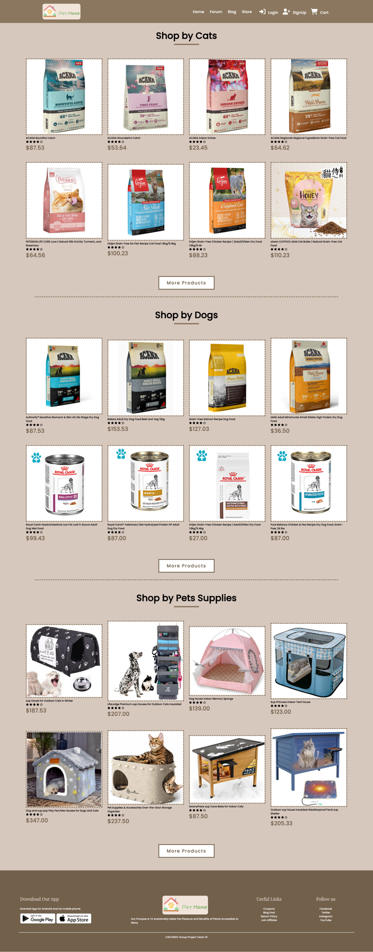

9) Post Page

* Fill in required content to post a blog (data stored in table ‘post’).
* Post can only be posted if the input Email exist in database.
* Post can only be posted if the input image file is fit with the regulation size (under 2,000,000 pixel).

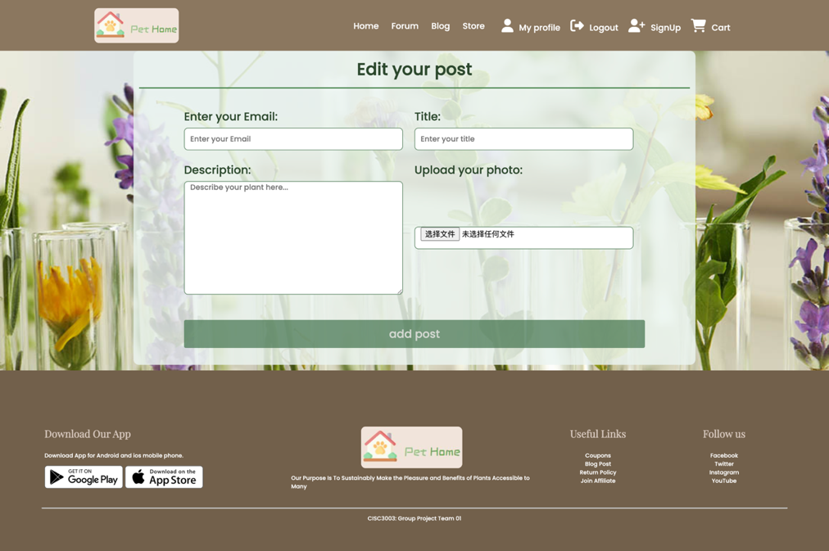

10) Profile Page

* The sign up information and post blog of the user
* Only visible in navbar if the user has logged in

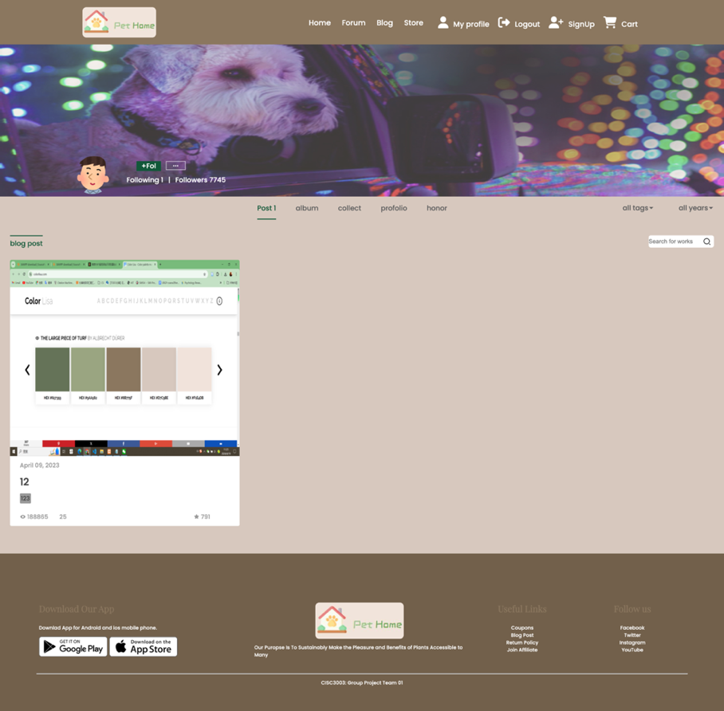

11) Shops by cats / dogs / pet supplies

* Present the items’ image, title, score and price
* Can click the image to enter product page

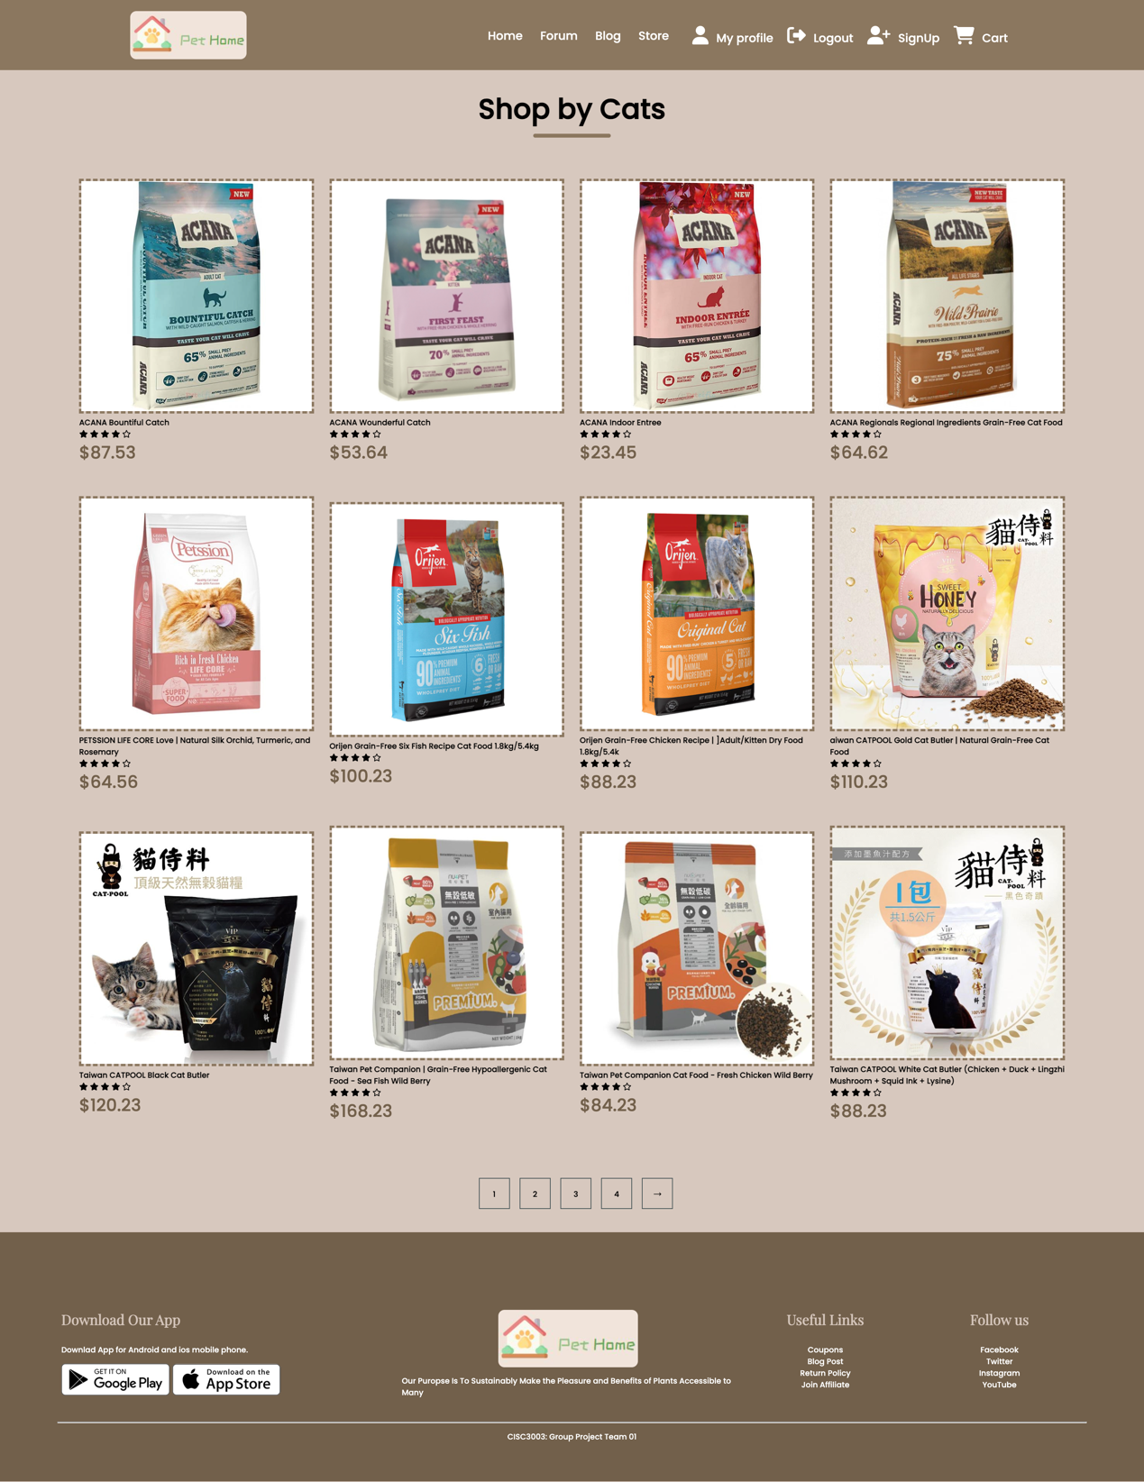

12) Product Page

* Present the image, title, price, detail of a single product
* Input field and button to select the number of item to add to cart.

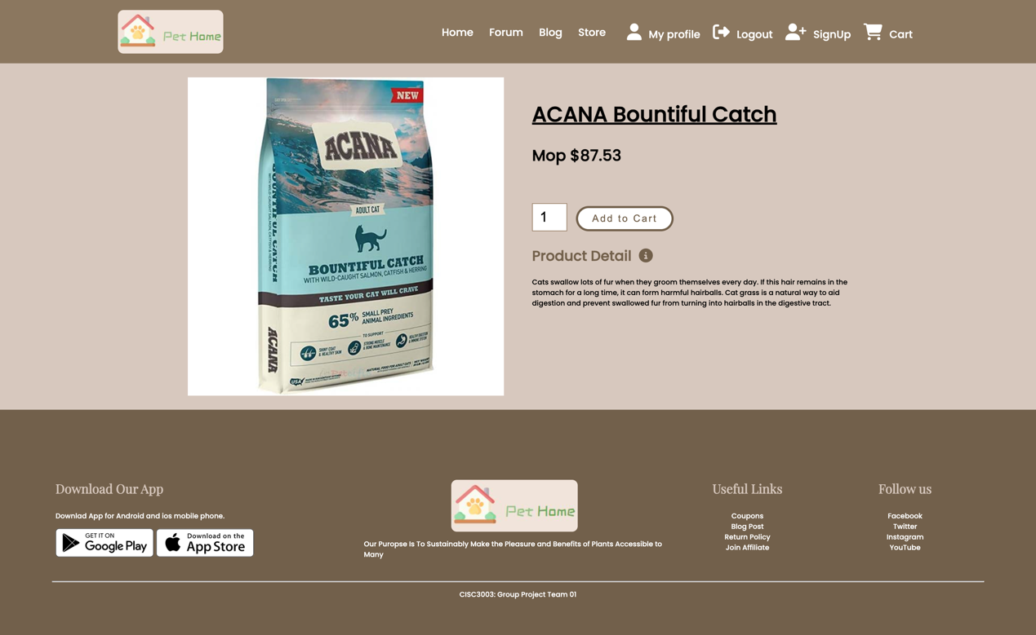

13) Cart page

* Only visible if the user logged in.
* Able to change the quantity of item.
* Able to compute the total price of the whole cart.
* Button to remove all content in cart.

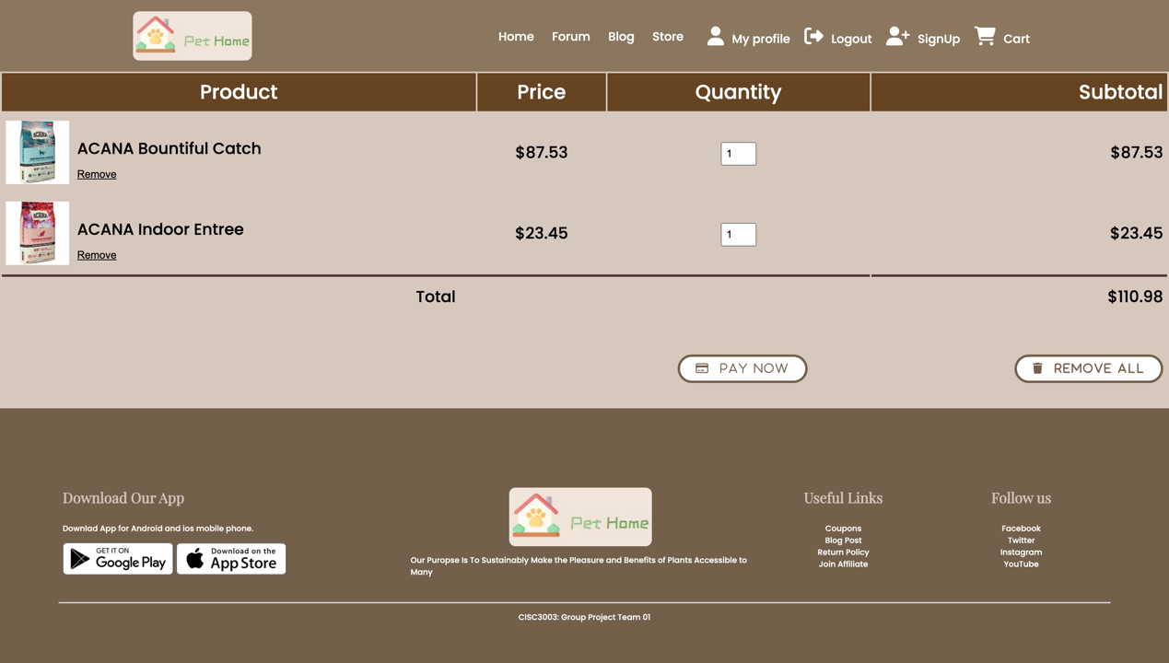

**Section 06: Project Installation Instruction**

* **Github link** [**https://github.com/keiran2343434/CISC3003-GroupProject-Team01**](https://github.com/keiran2343434/CISC3003-GroupProject-Team01)

**Description**

This E-Commerce platform is a fully functional web application developed as part of the CISC3003 course, following the Mr. Web Designer project walkthrough. It allows users to browse products, add them to a shopping cart, and proceed through a checkout process. The platform also includes an administrative interface for managing products and orders.

**Installation**

Prerequisites

- Apache server (XAMPP recommended)

- PHP (version 7.4 or higher)

- MySQL (MariaDB or MySQL proper)

Setup Instructions

1. Extract the project:

- Extract the project into your web server directory, typically `xampp/htdocs` if you are using XAMPP.

2. Setting up the environment:

- Start the Apache and MySQL modules via the XAMPP control panel.

3. Database Setup:

- Open phpMyAdmin from your XAMPP control panel.

- Create a new database named `shop_db`.

- Import the `shop_db.sql` file located in the `CISC3003-SemesterProject-Part2` directory. This file contains all the necessary tables and schema required for the application.

4. Configuring the Application:

- Ensure the `CISC3003-SemesterProject-Part2/project/uploaded_files` directory has appropriate write permissions set, as follows:

```

chmod -R 755 /path/to/xampp/htdocs/CISC3003-SemesterProject-Part2/project/uploaded_files/

```

- Adjust the database connection settings if necessary in `CISC3003-SemesterProject-Part2/project/components/connect.php`. Default settings:

```

php

$dsn = 'mysql:host=localhost;port=3306;dbname=shop_db';

$username = 'root';

$password = '';

```

5. Accessing the Project:

- Open a web browser and navigate to `localhost/CISC3003-SemesterProject-Part2/project` to access the application.

- Explore the functionalities like adding products, viewing products, managing the cart, and checking out.

**Features**

- Product Browsing: View a list of available products.

- Shopping Cart: Users can add products to their shopping cart and modify their selections.

- Checkout Process: A step-by-step process to complete the purchase.

- Admin Panel: Manage products and view orders.

**Additional Notes**

- Ensure all dependencies are installed and configured properly as per the prerequisites.

- The platform is designed to run in a local environment for demonstration and development purposes.

**Contact**

For any further assistance or queries, please feel free to contact the course instructor or the support team at your institution.

**Section 06 : Project Self-Assessment**

Part 1 Project Setup under Eclipse IDE

|  |  |  |  |
| --- | --- | --- | --- |
| Assessment Items | Item Examined | Item Score | Score Earned by:  Team 01 |
| 1. Select your Eclipse workspace at d:\cisc3003-2024\CISC3003-YourStudentID-2024, where YourStudentID is your student ID (in lower case letters and digits, say, dc251924). The file must exist within the "htdocs" folder of the server, and then the request will be "localhost/some-path/". | Test-run from Eclipse IDE | 1 | 1 |
| 2. Create your Eclipse project for this suggested exercise and name it " CISC3003-GroupProject-Team01" | Test-run from Eclipse IDE | 1 | 1 |
| 3. Create a folder under your project space and name it "images" | Test-run from Eclipse IDE | 1 | 1 |
| 4. Move all the image files for this project into the above "images" folder | Test-run from Eclipse IDE | 1 | 1 |
| 5. Create a folder under your project space and name it "css", another is named “js” | Test-run from Eclipse IDE | 1 | 1 |
| Score earned in Part 1 |  | 6 | 6 |

Part 2 Work Steps - Frontend Design

|  |  |  |  |
| --- | --- | --- | --- |
| Assessment Items | Item Examined | Item Score | Score Earned by:  Team 01 |
| 1. Start creating the six HTML pages by following the 1-page design format with the responsive design. | HTML visible from Eclipse editor, and Web browser | 12 | 12 |
| 2. Produce the different sections in your Web pages and corresponding css files, including the various styling rules for your different sections in your Eclipse HTML editor and CSS editor respectively. And put the css files in the folder "css" under the project space. | HTML/CSS files visible from Eclipse editors, and Web browser | 10 | 10 |
| 3. Render your Web pages in an external browser (e.g., Chrome, Firefox, or Edge). | HTML visible from Eclipse editor, and Web browser | 2 | 2 |
| 4. Add a footer section in the Web page produced in (4). | HTML visible from Eclipse editor, and Web browser | 2 | 2 |
| Score earned in Part 2 |  | 32 | 32 |

Part 3 Work Steps - Backend Design

|  |  |  |  |
| --- | --- | --- | --- |
| Assessment Items | Item Examined | Item Score | Score Earned by:  Team01 |
| 1. Create the php files "BlogPage.php", "CartPage.php", "ForumPage.php", “HomePage.php”,”Login.php”, "mailActivate.php", "navbar.php", "post.php", “ProductDetail.php", "rest.php", "signup.php", "StoreCatPage.php”, "StoreDogPage.php", "StoreService.php”, "user.php", “verify.php" | HTML source code visible from Eclipse editor, and Web browser | 16 | 16 |
| 2. Start editing the 16 PHP pages by following the 1-page design format with the responsive design. | HTML visible from Eclipse editor, and Web browser | 32 | 32 |
| 3. Creating the database in Xampp PhpMyAdmin, and connect it to the php. Edit the database and insert the needed testing data. | Database visible from Xampp PhpMyAdmin Web Page | 5 | 5 |
| 4. Produce the needed sections in your Web pages and corresponding css files, including the various styling rules for your different sections in your Eclipse HTML editor and CSS editor respectively. And put the css files in the folder "css" under the project space. | HTML/CSS files visible from Eclipse editors, and Web browser | 12 | 12 |
| 5. Create the “StorePage.php”, “Login.php” and “mailActivate.php”, “user.php”, “Forum.php” for the post function in the website. Edit the php files and connect to corresponding “webproject” database. | Database visible from Xampp PhpMyAdmin Web Page with Web browser page visible | 10 | 10 |
| 6. Render your Web pages in an external browser (e.g., Chrome, Firefox, or Edge). | HTML visible from Eclipse editor, and Web browser | 2 | 2 |
| Score earned in Part 3 |  | 77 | 7 |

Part 4 Test and Submission Steps

|  |  |  |  |
| --- | --- | --- | --- |
| Assessment Items | Item Examined | Item Score | Score Earned by:  Team01 |
| 1. Firstly, test your pages with different sections by seeing if its presentation follows the 1-page format. Be sure to test the responsive design by resizing the windows, and observing the changes in screen appearance. Capture your screens to prove your media queries work. | HTML visible from Eclipse editor, and rendered in Web browser | 15 | 15 |
| 3. Include the screen shots from (1) and (2) in a) the Eclipse project space (under a folder called "Our Screen Shots"), and b) in the sharing forum [CISC3003 Project Assignment Part 1 forum - Due on 2024MAY06 11:00 pm](https://ummoodle.um.edu.mo/mod/forum/view.php?id=3004581). | Screen shots captured and shared in the related forum | 12 | 12 |
| 3. Zip the folder (note the ".zip" extension is not part of the name | Do not use ".rar" format, but the ".zip" format) | Eclipse project space from your submission | 1 | 1 |
| 4. Submit your zipped file at [CISC3003 Submission Link for](https://ummoodle.um.edu.mo/mod/assign/view.php?id=3004584) this project | Submission Link | 1 | 1 |
| Score earned in Part 4 |  | 26 | 26 |

Part 5 Contents and Look-and-Feel Design Score

|  |  |  |
| --- | --- | --- |
| Item under Evaluation | Assigned Score | Earned Score |
| Home Page | 3 | 3 |
| Forum Page | 3 | 3 |
| Forum Page - Post detail | 3 | 3 |
| Blog Page | 3 | 3 |
| Store Page | 3 | 3 |
| Store Page (Cat) | 3 | 3 |
| Store Page (Dog) | 3 | 3 |
| Store Page (Pet Supplier) | 3 | 3 |
| Login Page | 3 | 3 |
| Login Page - Login Function | 3 | 3 |
| Signup Page | 3 | 3 |
| Signup Page - Singup Function, Email Validation Function | 3 | 3 |
| Cart Page | 3 | 33 |
| Cart Page – Add to Cart Function | 3 | 3 |
| Overall Style | 3 | 3 |
| Design of Navigation | 3 | 3 |
| Design of CSS files | 3 | 3 |
| Header and Footer in web pages | 3 | 3 |
| Images | 3 | 3 |
| Textual Information | 3 | 3 |
| Score earned in Part 5 | 60 | 60 |

Total Score – Team01

|  |  |  |
| --- | --- | --- |
| Item - Suggested Exercise 09 | Allocated Score | Your Earned Score |
| Part 1 Assessment on Project Setup under Eclipse IDE | 6 | 6 |
| Part 2 Assessment on Project Work Steps - Frontend | 32 | 32 |
| Part 3 Assessment on Project Work Steps - Backend | 77 | 77 |
| Part 4 Assessment on Project Test and Submission Steps | 26 | 26 |
| Part 5 Assessment on Contents and Look-and-Feel Design | 60 | 60 |
| Total Score | 201 | 201 |
| 100 Scale | 100 | 100 |
| Classification on Quality of Work | Good | |